**DATABASE MANAGEMENT SYSTEM MINI PROJECT 2**

The following work consists of development of front end and back end of a table from the application that I have submitted in Mini project 1. I used HTML to create the website and used php to save the data submitted in the website into the database. I used phpMyAdmin to create and show the contents of the database. I used MAMP server for this purpose. I have used Adobe Dreamweaver 2021 (trial version) to create html code.

I have created the website for a simple table from my application. The table is all about storing data from patient and the doctor he/she wants to attend. The attributes are Hospital Name, Doctor ID and Consultation time. Depending upon the doctor and consultation time, the user should get back the availability, ratings, etc., of the particular doctor.

**HTML code:**

<!doctype html>

<html>

<head>

<meta charset="utf-8">

<title>Untitled Document</title>

</head>

<body>

<form name="form1" action ="" method="post">

<table>

<tr>

<td>Enter Hospital Name </td>

<td><input type="text" name="t1" id="t1"></td>

</tr>

<tr>

<td>Enter Doctor ID</td>

<td><input type="text" name="t2" id="t2"></td>

</tr>

<tr>

<td>Enter your consultation time</td>

<td><input type="text" name="t2" id="t3"></td>

</tr>

<tr>

<td><input type="button" name="b1" value="submit" onClick="aa();"></td>

</tr>

</table>

</form>

<script type="text/javascript">

function aa()

{

var xmlhttp;

xmlhttp=new XMLHttpRequest();

xmlhttp.open("GET","insert.php?hnm="+document.getElementById("t1").value+"&did="+document.getElementById("t2").value+"&time="+document.getElementById("t3").value,false);

xmlhttp.send(null);

}

</script>

</body>

</html>

**Php code to insert data:**

<!doctype html>

<html>

<head>

<meta charset="utf-8">

<title>Untitled Document</title>

</head>

<body>

<?php

$hnm=$_GET["hnm"];

$did=$_GET["did"];

$time=$_GET["time"];

mysql_connect("localhost","root","");

mysql_select_db("testing");

mysql_query("insert into test values('$hnm','$did','$time')");

?>

</body>

</html>

**Database creation:**

After connecting to the MySQL server in MAMP, using phpMyAdmin a database for storing the data is created. The name of the database is testing. A table is created, named Hospital & Doctor, to store the record from the user.

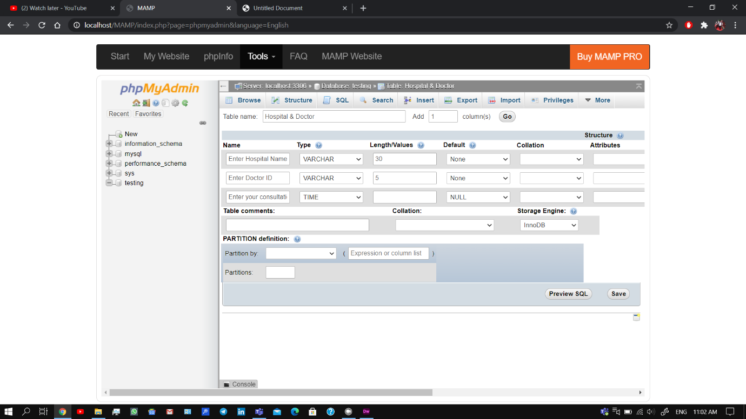

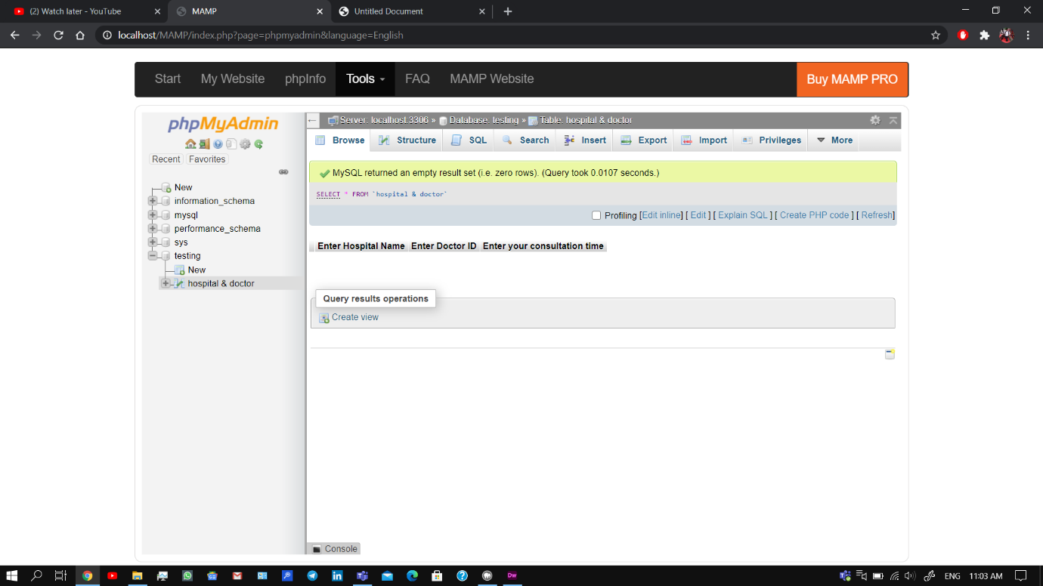

Website can be accessed by localhost sever.

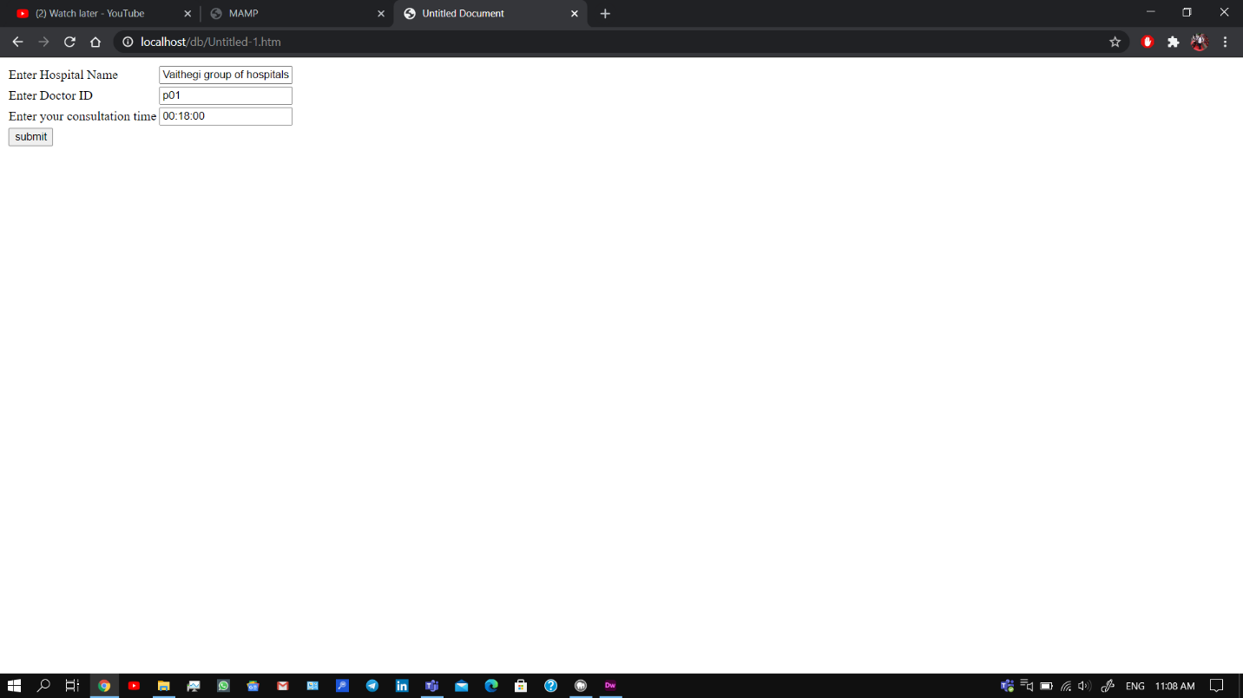

The record is stores in the database which can be browsed later as seen from the photo below:

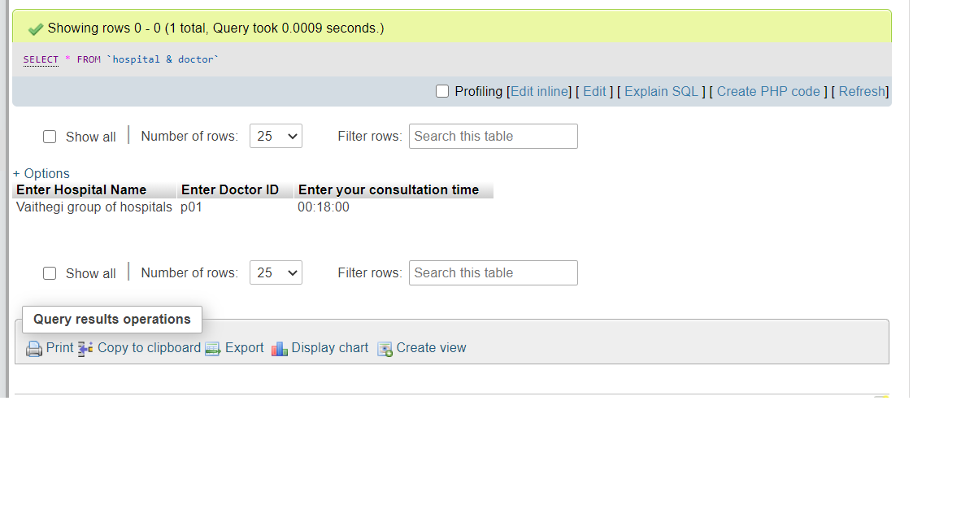

In this way, we can store as many inputs as we want from the site and give special privilege to patients of choosing their desired doctors.